**5.Create a simple cloud software application for Library book reservation system for SIMATS library using any Cloud Service Provider to demonstrate SaaS.**

**Aim:**

To create a cloud-based Book Reservation System in Zoho Creator that allows users to reserve or cancel books, automatically updating the book’s availability in real-time.

**Procedure:**

1. Create a Book form with fields:
   * Book Name
   * Author
   * Availability (Yes/No)
2. Create a Booking Details / Reservation form with fields:
   * Booking Status (Reserved / Cancelled)
   * Book (lookup to Book form)
   * User Details (optional)
3. Add a workflow on the Booking Details form that updates the Availability of the selected book when the booking status changes.
4. Test the system by reserving and cancelling books to ensure the Availability updates correctly.

OUTPUT :

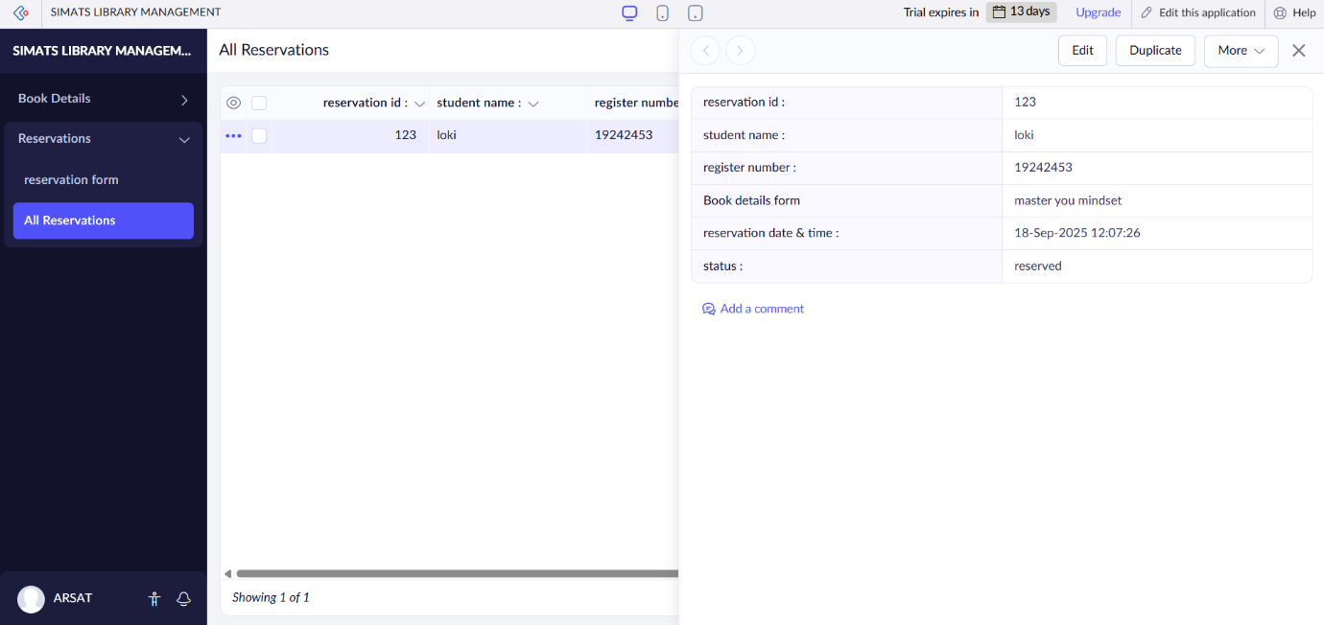

**Result:**

The system allows users to reserve or cancel books. The **Availability field of each book is automatically updated** based on the reservation status, ensuring accurate real-time tracking of available books.